### Creation of a RedShift Cluster

**Screenshots of the configuration of the RedShift cluster that you have created:**

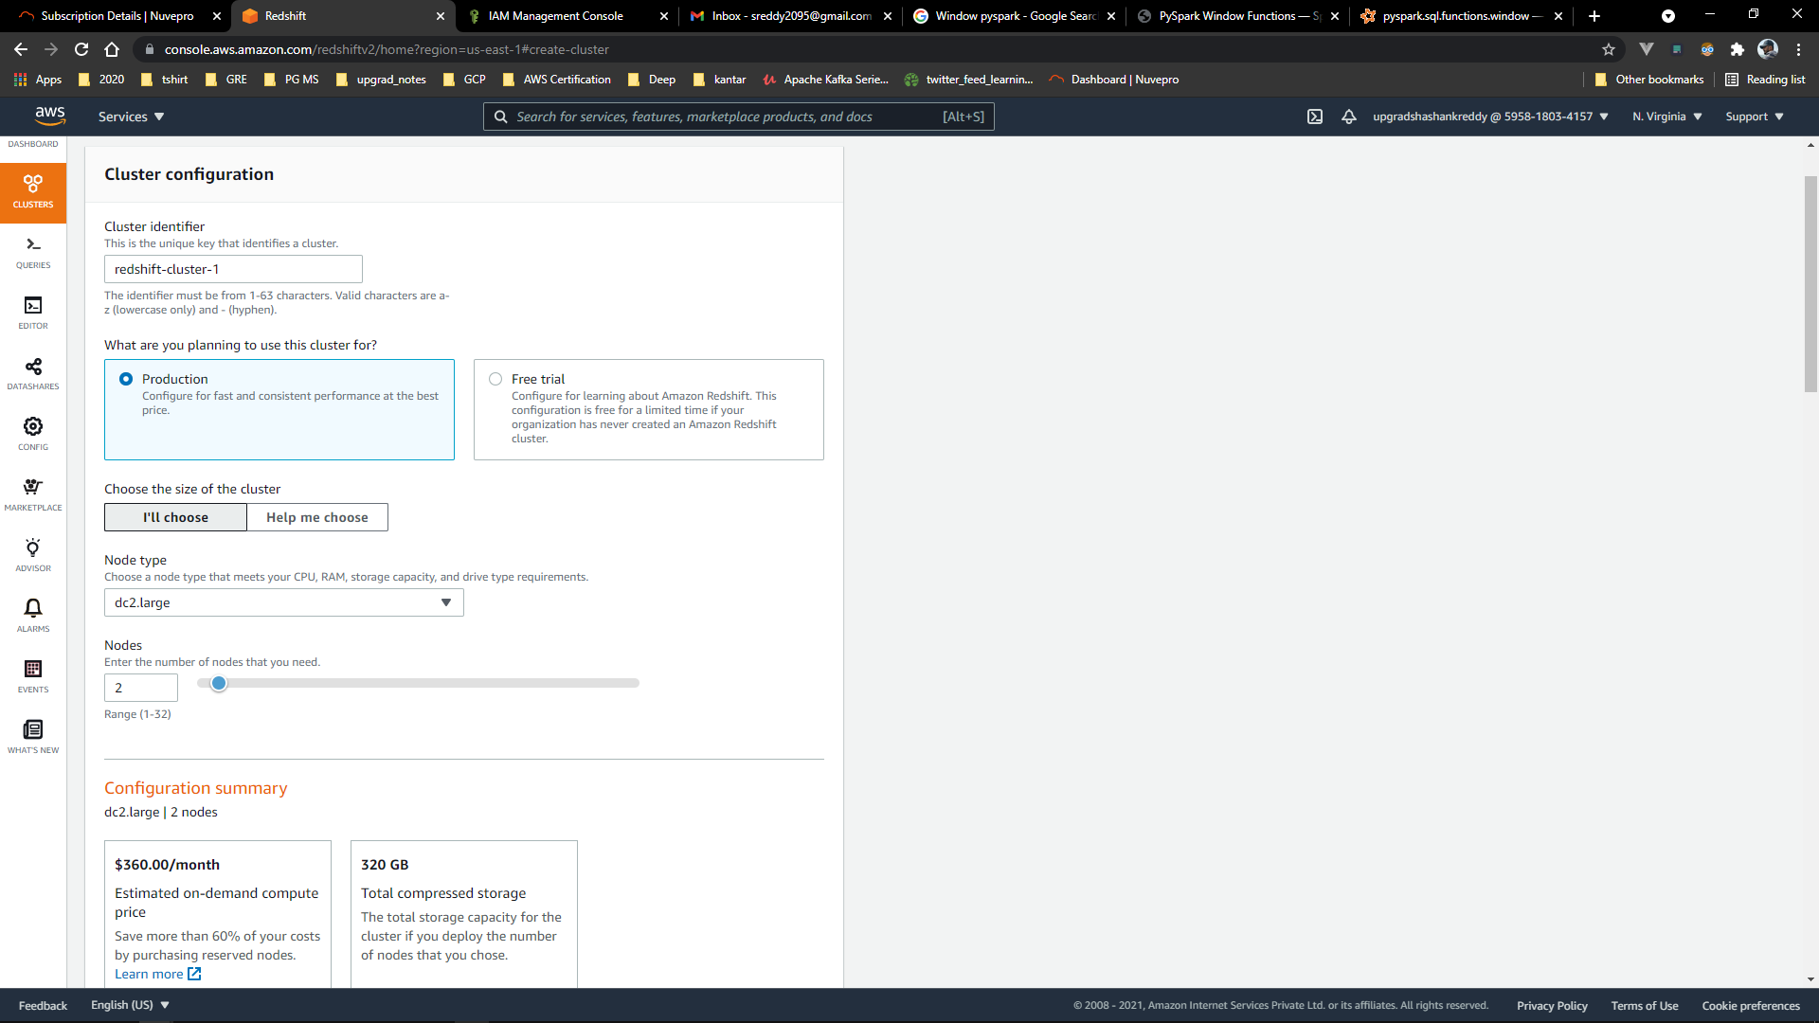

### 

### Setting up a database in the RedShift cluster and running queries to create the dimension and fact tables

**Queries to create the various dimension and fact tables with appropriate primary and foreign keys:**

1. **Creating Schema**

create schema etlschema;

1. **Creating Location Dimension Table**

create table etlschema.dim_location(

location_id int,

location varchar(50),

streetname varchar(255),

street_number int,

zipcode int,

lat decimal,

lon decimal,

primary key (location_id)

);

1. **Creating Card-Type Dimension Table**

create table etlschema.dim_card_type(

card_type_id int,

card_type varchar(50),

primary key (card_type_id)

);

1. **Creating Date Dimension Table**

create table etlschema.dim_date(

date_id int,

full_date_time timestamp,

year int,

month varchar(50),

day int,

hour int,

weekday varchar(50),

primary key (date_id)

);

1. **Creating ATM Dimension Table**

create table etlschema.dim_atm(

atm_id int,

atm_number varchar(20),

atm_manufacturer varchar(30),

atm_location_id int,

primary key(atm_id),

foreign key(atm_location_id) references etlschema.dim_location(location_id)

);

1. **Creating the Fact ATM Transaction Table**

create table etlschema.fact_atm_trans(

trans_id bigint,

atm_id int,

weather_loc_id int,

date_id int,

card_type_id int,

atm_status varchar(50),

currency varchar(20),

service varchar(50),

transaction_amount int,

message_code varchar(50),

message_text varchar(100),

rain_3h decimal(10,3),

clouds_all int,

weather_id int,

weather_main varchar(50),

weather_description varchar(255),

primary key(trans_id),

foreign key(weather_loc_id)references etlschema.dim_location(location_id),

foreign key(atm_id)references etlschema.dim_atm(atm_id),

foreign key(date_id)references etlschema.dim_date(date_id),

foreign key(card_type_id)references etlschema.dim_card_type(card_type_id)

);

### Loading data into a RedShift cluster from Amazon S3 bucket

**Queries to copy the data from S3 buckets to the RedShift cluster in the appropriate tables**

1. **Location Dimension Table**

copy etlschema.dim_location(

location_id,location,streetname,street_number,zipcode,lat,lon

)

from 's3://shnkreddy/dim-location/part-00000-eb7cc902-17c3-4895-9b11-9c6a5b0390ce-c000.csv'

iam_role 'arn:aws:iam::595818034157:role/redshift_s3_fullaccess'

delimiter ',' region 'us-east-1' CSV;

1. **ATM Dimension Table**

copy etlschema.dim_atm

from 's3://shnkreddy/dim-atm/part-00000-2c7564c6-b985-499c-97d0-936c1bd81da9-c000.csv'

iam_role 'arn:aws:iam::595818034157:role/redshift_s3_fullaccess'

delimiter ',' region 'us-east-1' CSV;

1. **Card Type Dimension Table**

copy etlschema.dim_card_type

from 's3://shnkreddy/dim-card-type/part-00000-81965790-3bf7-4eb6-bdc1-37002762c0d0-c000.csv'

iam_role 'arn:aws:iam::595818034157:role/redshift_s3_fullaccess'

delimiter ',' region 'us-east-1' CSV;

1. **Date Dimension Table**

copy etlschema.dim_date

from 's3://shnkreddy/dim-date/part-00000-e64864de-8000-4129-8a59-2059bb5f8b01-c000.csv'

iam_role 'arn:aws:iam::595818034157:role/redshift_s3_fullaccess'

delimiter ',' region 'us-east-1' TIMEFORMAT AS 'YYYYMMDDHHMISS' CSV;

1. **Fact Table**

copy etlschema.fact_atm_trans

from 's3://shnkreddy/fact-table/part-00000-954a52c1-346a-4f62-adf2-1645d650c796-c000.csv'

iam_role 'arn:aws:iam::595818034157:role/redshift_s3_fullaccess'

delimiter ',' region 'us-east-1' CSV;